Hello Science Club Member,

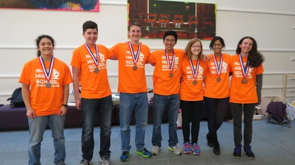
Welcome to the 2014-2015 Avon High School Science Club. We’re a dedicated group of students unified by a passion for the sciences. We explore, develop, and express these passions beyond the classroom through a wide variety of opportunities. These opportunities range from competitive state Quiz Bowls and the U.S. Biology Olympiad to casual after-school lectures with local researchers and students. Apart from personal development, our club also focuses on communal development of scientific interest. The following pages will describe these various opportunities, so that you can select those that most interest you. This allows club leadership to cater to your interests as best we can.
As a group, we emphasize the fostering of a supportive community so that students may comfortably tackle otherwise overwhelming tasks and ultimately surpass personal goals. This environment is also conducive to the development of many skills required in the contemporary scientific community. In addition to a strong club identity, we encourage camaraderie between participants on our various event teams. We find that this creates both greater success and more importantly, a more enjoyable experience.
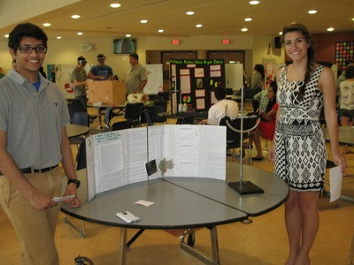
Our teacher advisors are Mrs. Galuska, Mrs. Loynes, and Mr. Dunford, and entire club meetings are usually held in Mrs. Galuska’s room: N200. We can be found online at www.avonhighscienceclub.weebly.com. Our funding comes from generous parent donations and Connecticut Science Center ticket sales through our club. Thank you, and we hope you enjoy taking part in the 2014-2015 Avon High School Science Club!
Sincerely,
Your Leadership Team
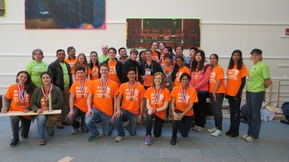
Team Science Olympiads
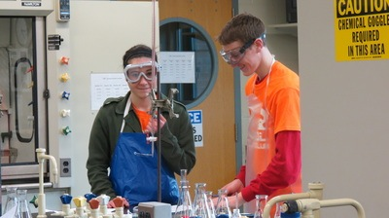
The Team Science Olympiads include a Yale Invitational competition (January) and the state-level competition at UCONN (Late March) every year. Our science club fields 2 teams, each comprised of 15 dedicated students, who represent the school in multiple events across various disciplines. There are in excess of 20 events but only 15 students per team, so participants are expected to prepare for 2-3 events. This preparation process occurs over a longer time frame (multiple months), as we understand the busy high school schedule. This being said, the longer time frame also means competitors are expected to have thorough preparation documented in some paper form (this comes in handy anyway, as many events allow for cheat sheets). These events may be laboratory based investigations, written exams, or exhibitions of previously built mechanisms.
Last year, both of our teams placed well within the top 10 in the state. We are looking to improve our ranking, but emphasis is still placed on enjoying the experience. Apart from team rankings, individuals are also ranked within each event. The top three scorers in each event receive awards. We consistently contend for these awards as well.
Ultimately, the Team Science Olympiads are fun, one-day events with friendly competition, where preparation in the long run can yield satisfying rewards. Good luck!

Individual Olympiads
The Individual Olympiads are the Biology Olympiad (February), the Chemistry Olympiad (March Break), and the Physics Olympiad (Likely in January). These are exam competitions administered to students on a national scale. The top portion of performers are invited to participate in subsequent rounds. Eventually, these rounds lead to competing with the United States team on an international scale. These exams are traditionally difficult, and require serious studying or training. Due to their rigor, performing well on these exams is regarded as very impressive, especially to potential admissions committees. Club advisors are invaluable when preparing for these competitions.

Science Quiz Bowl
The Science Quiz Bowl (April) is an annual competition between high schools from around the state. Avon High School fields a team of five highly competitive students, usually consisting of two seniors, one junior, one sophomore, and one alternate. The competition is in fast-paced verbal format where students solve technical problems and answer questions in all branches of mathematics and sciences. This competition is organized by the U.S. Department of Energy and culminates in a national competition. Last year our team placed third in the state, and we intend to improve in the rankings. Like the Team Science Olympiads, serious commitment is required for mastering a large breadth of knowledge.

School Science Fair
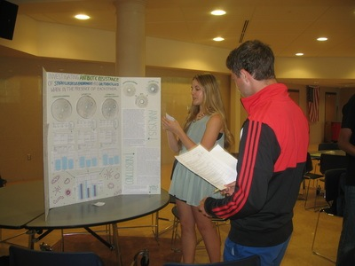
The Science Fair (Likely in May or early June) is an annual event run by members of the Avon High School Science club, that provides an opportunity to exhibit individual or small group projects in the Avon community. Traditionally, there are both high school and middle school divisions. Science Club members are encouraged to actively serve as a mentor for middle school scientists. The judging committee is comprised of experienced upperclassmen and Science Club alumni from leading colleges and research universities, and awards are provided for the highest scoring projects. In addition, projects that are notable for other attributes are also recognized. This event also serves as a stepping stone for the state-level science fair that occurs the following year. At this level, projects are evaluated by adjudicators amongst projects of similar subject area by similarly aged peers. Apart from adjudicators, many STEM companies located in Connecticut evaluate the projects and award scholarships for various qualities.
Envirothon
Envirothon (May) is a natural resource based competition new to Avon Science Club. High School Students work in teams led by a teacher/advisor. During the school year, teams receive curriculum materials and are invited to a series of training workshops. These workshops are presented by foresters, soil scientists, aquatic ecologists, wildlife biologists, and many others. In May, teams meet for an all day field competition at a park, camp or nature preserve. They are challenged to work together to answer questions and conduct hands-on investigations. Each team also prepares a short oral presentation on a real life environmental problem to present before a panel of experts. The winning team earns the chance to represent Connecticut at the North American Envirothon, a weeklong event held at a college campus in the summer. They compete with about 60 teams from across the USA and Canada for scholarships and other prizes. Many Envirothon Alumni go on to further study leading to environmental careers and are eligible for special scholarships.

Guest Speakers
Avon High School Science Club hosts various guest speakers throughout the year. These usually involve scientists in the community who come and give a presentation on or demonstration of their work. Topics cover a broad range. Last year we had everything from a biologist researching bone regeneration to a team of material science students performing demos with various materials. These events expose students to disciplines outside of high school academia while providing a taste of the modern scientist’s life. Following the presentation is traditionally a constructive Q&A session. The speakers are also approachable one-on-one after the presentations. In addition, many of the guests have experience in higher education, so their input is invaluable to high school students that are thinking of attending college and even graduate school. Because of these factors, these lectures are very advantageous to any students interested in science. Also, we do not want to waste the guests’ time so large attendance is preferable. Therefore, attendance is highly encouraged. If we provide enough opportunities, it is possible that attendance will be required for a portion of the events (you’ll be there anyways because they’re fun). Also, there’s food. These presentations have even garnered the attention of non-science club members (who are certainly welcome). This is often a favorite activity of science club members.

Field Trips
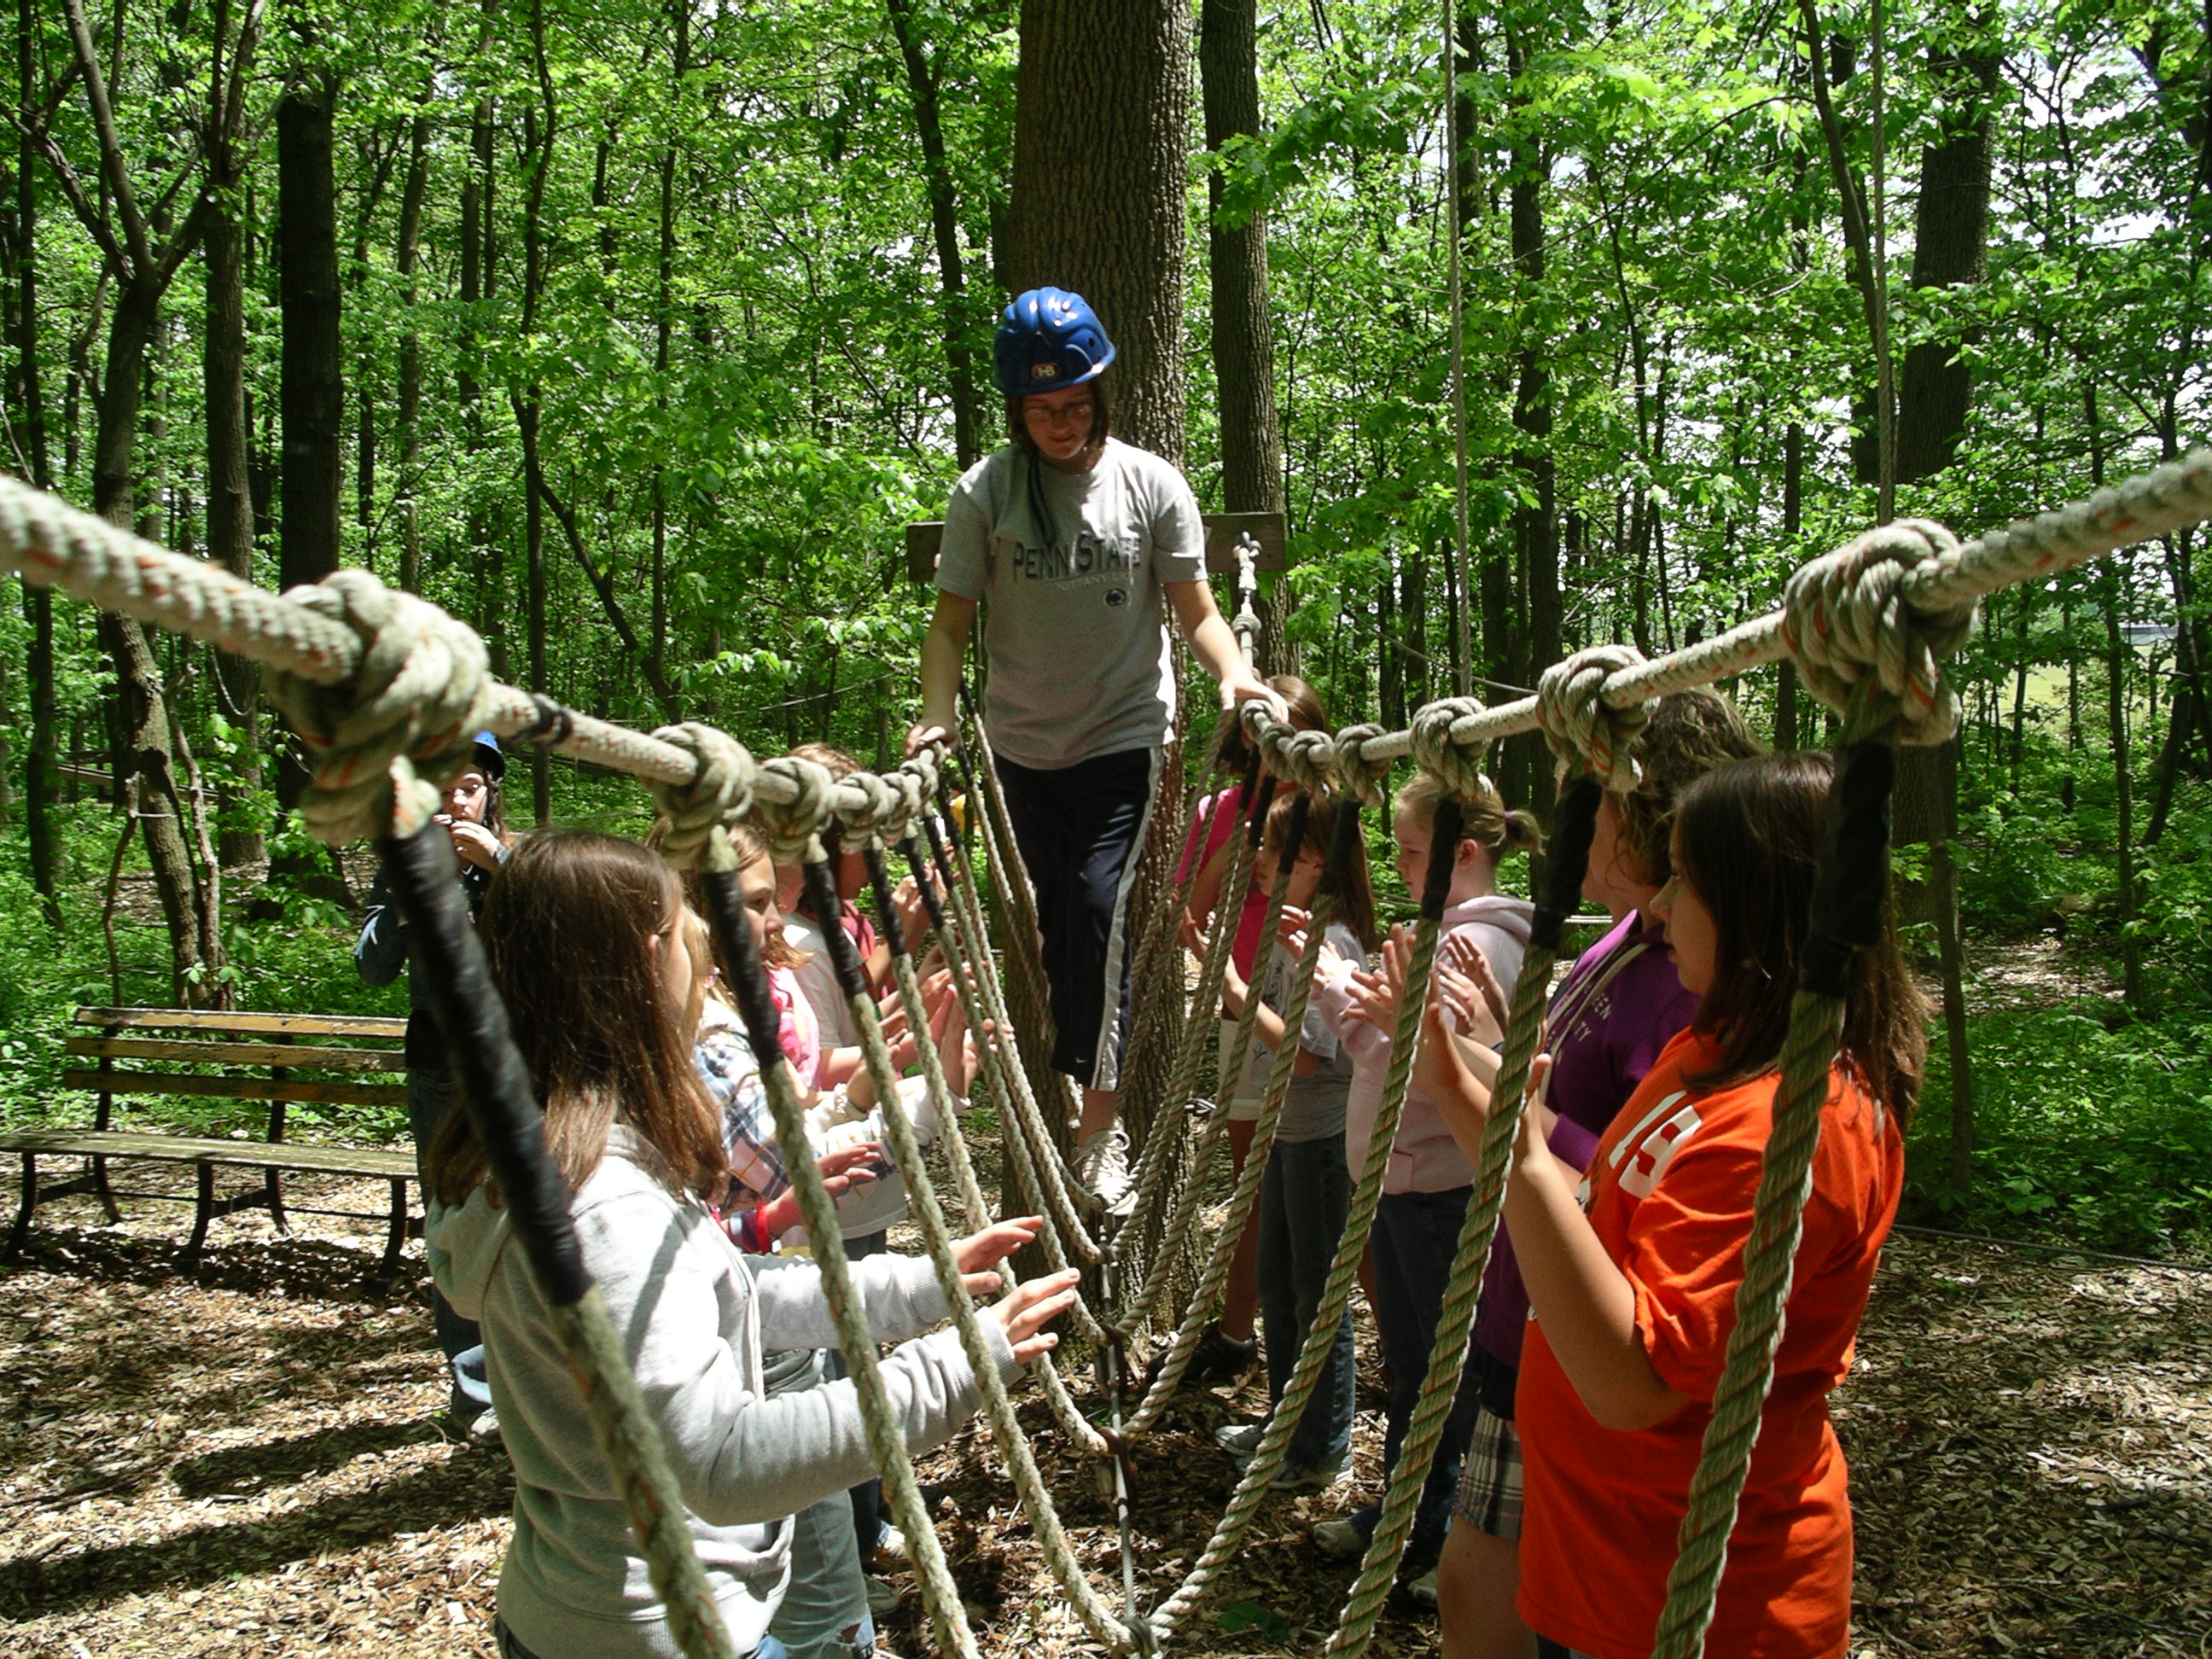
Field Trips happen throughout the year and provide students the opportunity to experience science beyond the classroom. Field Trips may include visiting the State Science Fair (which is accompanied by a demonstration), rope courses for building team camaraderie, laboratories in the surrounding area, science exhibits, etc.. We schedule these based on displayed student interest. If you have any ideas, feel free to specify on your Interest Inventory or notify a teacher or someone on the leadership team.

Movie/Pizza Nights
In addition to other activities, the Science Club would like to host Movie/Pizza Nights to create unity among Science Club members and the individual teams. These events combine a constructive goal with the fun of watching a movie with your friends! Frequency and timing will be based on demonstrated interest. Movies are not restricted to pure documentaries.

